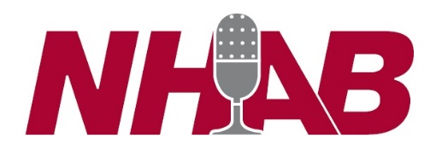
Student Broadcaster Scholarship Program
Our Association is committed to encouraging students who are interested in radio or television to further their education. Students interested in a career in over-the-air broadcasting are encouraged to apply for a scholarship from the New Hampshire Association of Broadcasters, Inc. (NHAB). What is the New Hampshire Association of Broadcasters? Established in 1954, the New Hampshire Association of Broadcasters is a non-profit trade organization for over-the-air radio and television stations. NHAB promotes broadcasting as a viable career choice. Who should apply for the Student Broadcaster Scholarship? Students who are permanent residents of New Hampshire and are in the process of enrolling, or are currently enrolled, at an accredited institution of higher learning are encouraged to apply for a $2,500 scholarship. Such institutions include vocational schools, 2- or 4-year colleges or universities offering degrees in radio and television broadcasting. Applicants must meet their school’s status of a full-time student. The school does not need to be in the Granite State. The Al Sprague Memorial Scholarship was established to honor the former President of NHAB who died in 2008. Mr. Sprague left his mark on broadcasting in the Granite State and to honor his legacy, one $5,000 scholarship will be awarded annually to the student who shows the most promise in industry advocacy, leadership and entrepreneurship.

The selection process for scholarships will take into account such factors as financial need, academic merit, community service, extracurricular activities and work experience. Applications are reviewed and selected by broadcasters who have contributed financially to the NHAB Student Broadcaster Scholarship Program.
Scholarship payments will be made payable to both the student and the school and will be awarded in time for the 2024 fall semester. Students receiving a scholarship will be contacted in writing and a check presentation will be arranged.
Additional copies of this application are available at nhab.org.
Application deadline: Friday, April 5, 2024 to:
NHAB P.O. Box 5578 Manchester, NH 03108
OR: Submit on line
NHAB is not responsible for materials mailed separately. Applications that are incomplete or late will not be considered.

Personal Information
Student Name: ______________________________________________________________________
Mailing Address: ______________________________________________________________________
Email Address: ______________________________________________________________________
Phone: _____________________________________________________________________
Birth Date: ______________________________________________________________________
I am a: _____ high school senior _____ undergraduate student
High School: _________________________________________________________________________ school name/state/graduation date
School You Plan To Attend in Fall: _____________________________________________________________________ school name/state/expected graduation date
My School is a: _____ 4-year college or university _____ 2-year college _____ voc-tech school
I will be a: _____ freshman _____ sophomore _____ junior _____ senior
Field of Study: _______________________________________________________________________
Activities: list community & school activities in which you have participated. Include sports, student government, volunteer and community projects, etc. (Attach additional sheets if necessary) ____________________________________________________________________________________
____________________________________________________________________________________
____________________________________________________________________________________
____________________________________________________________________________________
Work Experience: (or enclose current resume) ____________________________________________________________________________________
____________________________________________________________________________________
____________________________________________________________________________________
Briefly state why you have chosen to pursue a career in a broadcast-related field: (Attach additional sheets if necessary) ____________________________________________________________________________________
____________________________________________________________________________________
____________________________________________________________________________________
____________________________________________________________________________________
If applying for the Al Sprague Memorial Scholarship, please indicate why you believe you are a good candidate: (Attach additional sheets if necessary)
____________________________________________________________________________________
____________________________________________________________________________________
____________________________________________________________________________________
____________________________________________________________________________________
____________________________________________________________________________________
High School Students Only TO BE FILLED OUT BY A HIGH SCHOOL OFFICIAL Student ranks ____________ in a class of ____________ Cumulative GPA ____________ (4.0 scale) PSAT/SAT __________ (critical reading) __________(math) __________(writing)
Signature, Title & Date: _________________________________________________________________
Transcript If you are a graduating high school senior, or have never enrolled in college, you must include a high school transcript. If you are now enrolled, or have ever been enrolled as a college student, please include your most recent college transcript. The transcript need not be an official copy, but it must be cumulative and show most recently completed study. TRANSCRIPTS MUST BE INCLUDED WITH APPLICATION.
Family Financial Statement If you are a dependent student, please have your parents complete the PARENT INFORMATION section using information from their most recent IRS Tax Return. Independent students and dependent students must complete the STUDENT INFORMATION section with information from your most recent IRS Tax Return. You are a dependent student if you are under 24 years of age.
PARENT INFORMATION
Adjusted gross income: _____________________
Total US income tax paid: ___________________
Total number of family members: _____________
STUDENT INFORMATION
Adjusted gross income: _____________________
Total US income tax paid: ___________________
Total number of family members: _____________
Total number of family members who will be attending college during the next academic year: ________

Describe personal or family circumstances that make it necessary for you to seek aid for your education: (attach additional sheet if necessary)
____________________________________________________________________________________
____________________________________________________________________________________
____________________________________________________________________________________
____________________________________________________________________________________
____________________________________________________________________________________
____________________________________________________________________________________
Certification I certify that the information on this form is true and complete to the best of my knowledge. If asked by any authorized representative of the NHAB, I agree to give documentation for information given on this form. I realize that this proof may include a copy of a US tax return. I understand that the New Hampshire Association of Broadcasters will consider the financial information confidential.
Applicant Signature & Date: ____________________________________________________________
Award recipients will be notified no later than Friday May 31, 2024.

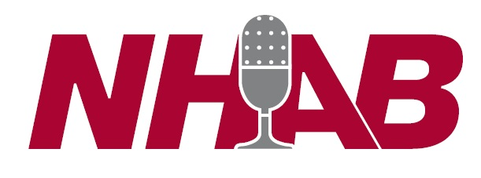

P.O. Box 5578, Manchester, NH 03108 603-232-0277 • www.nhab.org Facebook @NHBroadcasters

