Families in Broadcasting Scholarship

The New Hampshire Association of Broadcasters Families in Broadcasting Scholarship (FBS) was created to aid members as their children pursue higher education. This year, the NHAB will award $500 scholarships to graduating high school seniors through college students entering their senior year in Fall 2023. Students must complete this application, including essay and high school and/or college transcripts and submit it to the NHAB offices no later than Friday, April 21, 2023, to be eligible. A committee of State Association Broadcaster Executives will determine the winners.

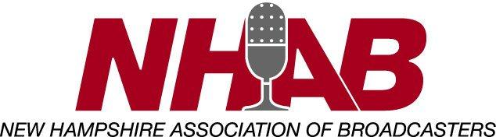
Who may apply:
• A high school senior through college junior, who will attend any post-secondary institution (vo-tech, two-year community college, four-year college or university/private or public; in state or out-of-state) in the Fall of 2023
• Major or field of study is not a determining factor
• Station General Manager must certify that applicant is a child of a full-time station employee (in continuous full-time employment as of July 1, 2022)
Return to: NHAB PO Box 5578 Manchester, NH 03108 or by submitting online.
Must be postmarked by Friday, April 21, 2023. We will not accept faxed applications.

PLEASE TYPE or PRINT LEGIBLY Student
Applicant’s Name________________________________________________________________ Address______________________________________________________
Tel No (________)____________________ City________________________ State_____ Zip_____________ Email _____________________________________
Student’s Parent/Legal Guardian Name___________________________________________________________
Tel No (_______)__________________ Address_____________________________________
City _____________________State__________Zip___________ Employed full time at which NHAB Member Station? ____________ For how long? _____________ years/mos.

*PLEASE INCLUDE A COPY OF YOUR MOST RECENT HIGH SCHOOL AND/OR COLLEGE TRANSCRIPTS
School
You will graduate this coming spring from which High School?____________________________ / N/A
Post-secondary school you will attend next fall?____________________________________________
School Address_________________________________________________
School Tel No (______)______________
Activities (Use additional pages, if necessary) List school and community activities, including clubs and offices you have held: __________________________________________________________________________________________________________________________________________________________________________
List honors and other accomplishments:
__________________________________________________________________________________________________________________________________________________________________________
Essay
Please attach an essay that addresses the following:
• In what ways have you been influenced or benefitted from your parent/legal guardian being in the broadcast business?
• What career do you plan to pursue, and why?
• Why should we award you $500 towards your education?
I certify the information on this application and attachments is true and correct to the best of my knowledge.
Applicant’s Signature ____________________________________________
Station/General Manager Certification
I certify this applicant is the child of an employee who has been in continuous full-time employment as of July 1, 2022.
Name__________________________ Station______________ ____________________________ (Please type) (Signature)
The Selection
The FBS Selection Committee will review the applications and essays and respond to applicant by June 2, 2023. Payment will be made to the student AND post-secondary institution.
*For additional applications or for more information, please visit nhab.org.

