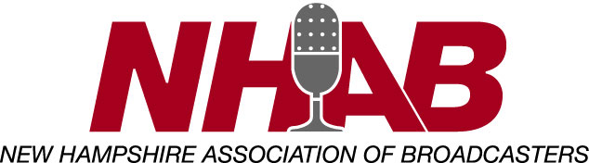

Scholarship Rate Sheet for New Hampshire Television Stations
(per set of call letters)

Television
Network Affiliated $1100
Non Network $800
Public $1000

Yes, _________________________ located at _____________________________
call letters address

will participate in the 2023 NHAB Student Broadcaster Scholarship Program.

I, ___________________________ understand that by committing to the four
General Manager

responsibilities previously noted in the attached letter, that my station(s) will earn one full

credit. Please find my check made payable to the NHAB in the amount of $___________

enclosed.

Dated _________________________

Signed ______________________________________

