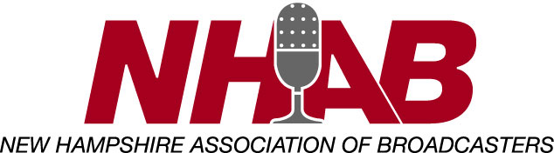

Scholarship Rate Sheet for New Hampshire Radio Stations
(per set of call letters)

Radio
AM $150
FM $300
Public $300
College Stations $50
High School Stations $25

Yes, _________________________ located at _____________________________
call letters address

will participate in the 2023 NHAB Student Broadcaster Scholarship Program.

I, ___________________________ understand that by committing to the four
General Manager

responsibilities previously noted in the attached letter, that my station(s) will earn one full

credit. Please find my check made payable to the NHAB in the amount of $ __________

enclosed.

Dated _________________________

Signed ______________________________________

